Site Search v1.1.2

User Guide

# Introduction

Site Search is a single user desktop application that is intended to allow shopping sites to be searched for potentially infringing content relating to illegal wildlife trade. Once a search has been successfully performed, the results themselves can be further searched or examined more closely. All of the results are retained unless intentionally removed.

The capabilities of the shopping sites themselves are used to perform the searches and the results returned are based on the sites own search mechanism. Only the top 100 entries at the most are currently returned for each search. This may be the first page of results for a site or a single scroll down where a site has a continuous search results page.

# Requirements

Site Search may be installed on either macOS Ventura or Window 8,10 or 11. On Windows, it installs for a single user with the data being held for that user only. To operate, a subscription is required to the ScrapingBee service, and the corresponding API key must be set as described in the section “Setting an API Key”.

A subscription to the ScrapingBee service can be obtained at: <https://www.scrapingbee.com>

With monthly subscription plans describe at: <https://www.scrapingbee.com/#pricing>

The pricing details section also gives details for obtaining 1000 free API credits to try out the service before fully subscribing.

# Supported Sites

Fifteen sites are currently defined within the application. The default request location and support status of these sites is as follows:

|  |  |  |
| --- | --- | --- |
| Site | Default geolocation | Status |
| Alibaba | China | Supported |
| Bukalapak | Indonesia | Supported |
| Carousell | Singapore | Supported |
| Shopee Brazil | Brazil | Available* |
| Shopee Chile | Chile | Available* |
| Shopee Columbia | Columbia | Available* |
| Shopee Indonesia | Indonesia | Available* |
| shopee malaysia | Malaysia | Pending |
| Shopee Mexico | Mexico | Available* |
| shopee philippines | Philippines | Pending |
| Shopee Singapore | Singapore | Available* |
| Shopee Taiwan | Taiwan | Pending |
| Shopee Thailand | Thailand | Pending |
| Shopee Vietnam | Vietnam | Pending |
| Tokopedia | Indonesia | Supported |

*Some Shopee sites are available but have a higher than acceptable failure rate.

# Windows Installation

The Site Search application can be installed on 64-bit Windows 8, 10 or 11 by running the “SetupSiteSearchWin64.exe” installation application. This application will guide you through the process of installation through a series of dialogues.

**Note** - The installation should be performed as the intended user for the software and *not* as an administrator. The very final stage of the installation may require administration privileges in order to install the “Visual C++ Windows Runtime Redistributable” if it is not already present but will prompt if required.

If the installation appears to stall on the last dialogue, then check the task bar for a confirmation to install the “Visual C++ Windows Runtime Redistributable”. This often takes the form of a blinking shield icon.

# macOS Installation

The Site Search application can be installed on macOS Ventura or later by copying or moving the “SiteSearch” application bundle to a suitable folder (normally the “Applications” folder).

Depending on the security settings of the machine being used, a warning message may be displayed stating that “Site Search may be damaged and can’t be opened”. If this is the case, then cancel out of the message dialogue and run the command below from the terminal:

**xattr -d com.apple.quarantine /Applications/Site\ Search.app**

The command above assumes that Site Search has been installed in the Applications folder. If it has been installed elsewhere, then the “/Applications/Site\ Search.app” path above will need to be changed accordingly.

# Setting an API Key

This version of the Site Search desktop application requires that an API key is set in order to use the ScrapingBee service. To set this key, go to the “File -> API Key…” menu option and set the key in the dialogue that appears.

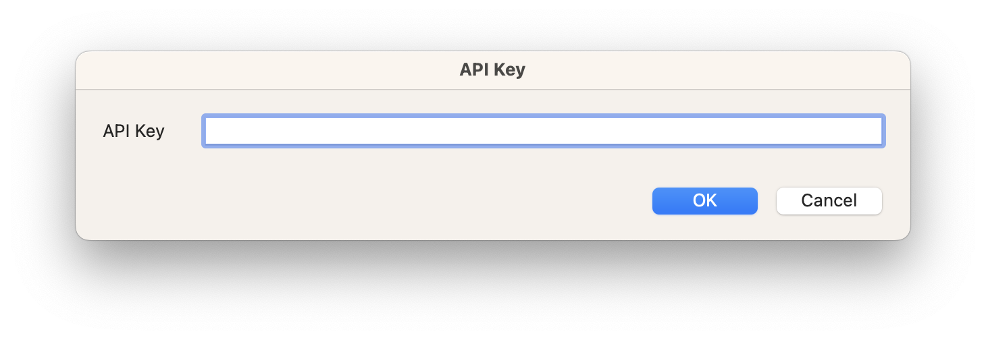

Once the key has been entered in the “API Key” field, press the return key or click on the “Ok” button to set it.

The API key can be found at: <https://app.scrapingbee.com/dashboard>

# Starting a Site Search

A new site search can be initiated from the main application window (this is the first window displayed when starting the application).

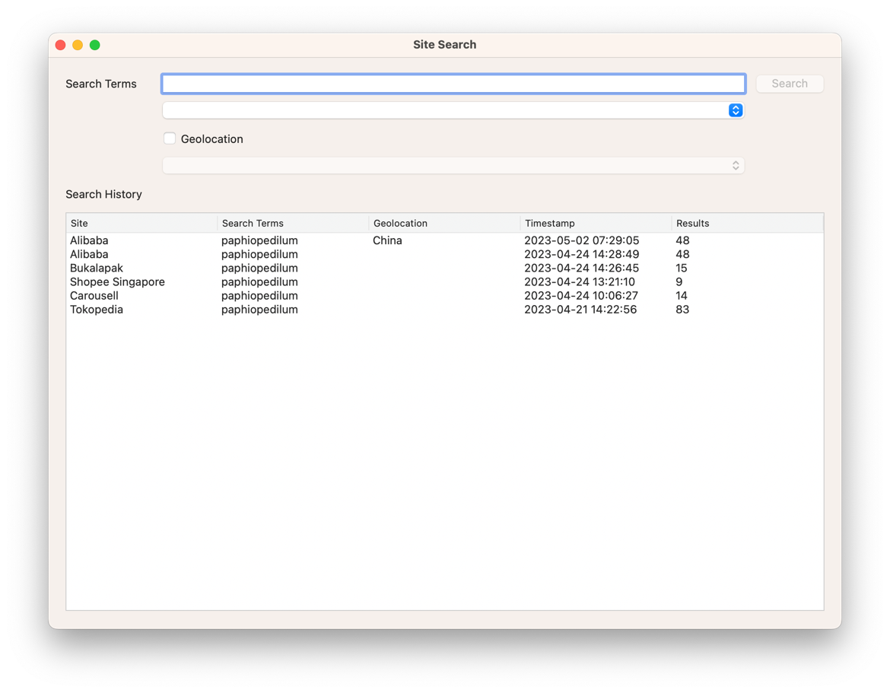

Simply enter the required search terms in the “Search Terms” field and then select the site to search in the drop-down list below.

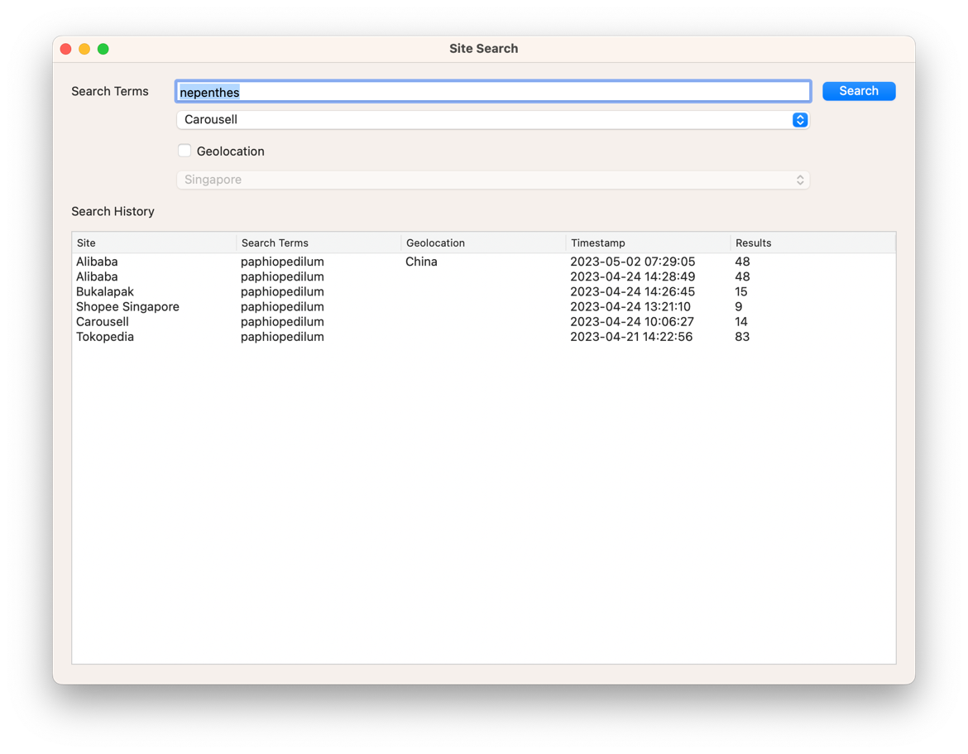

Once both of these details have been entered, then the “Search” button will be enabled, and the search can be started by either pressing the return key or clicking on the button.

A progress wheel will be displayed while the search is taking place and all of the control on the window will be disabled.

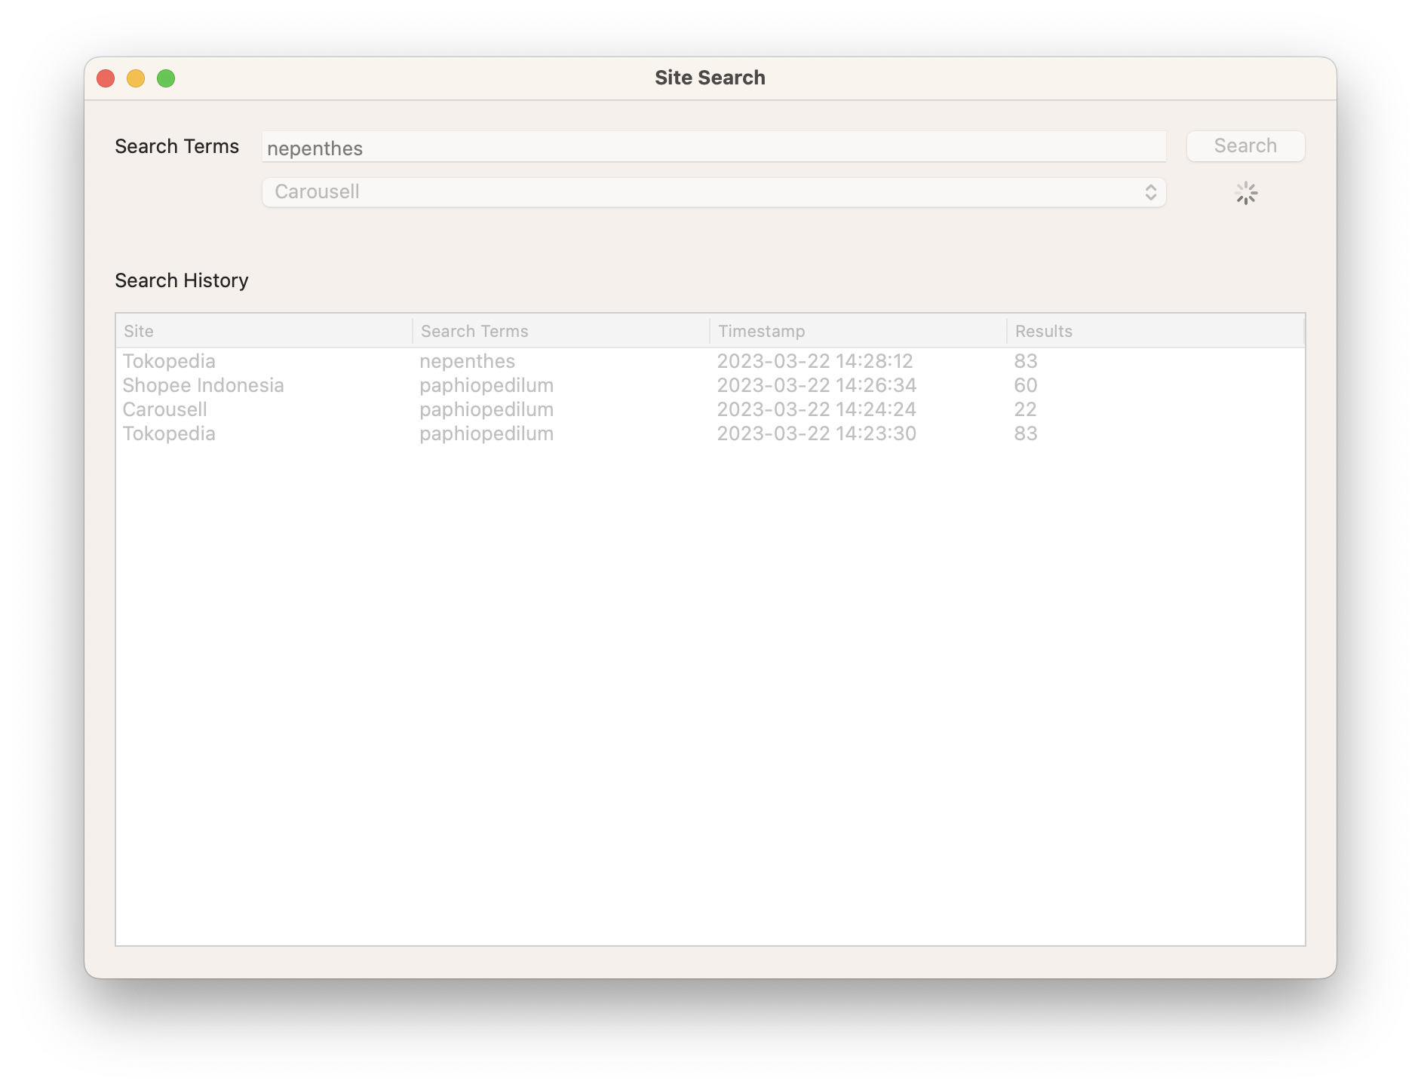

A new entry will appear in the “Search History” list and all of the controls will be enabled when the search completes.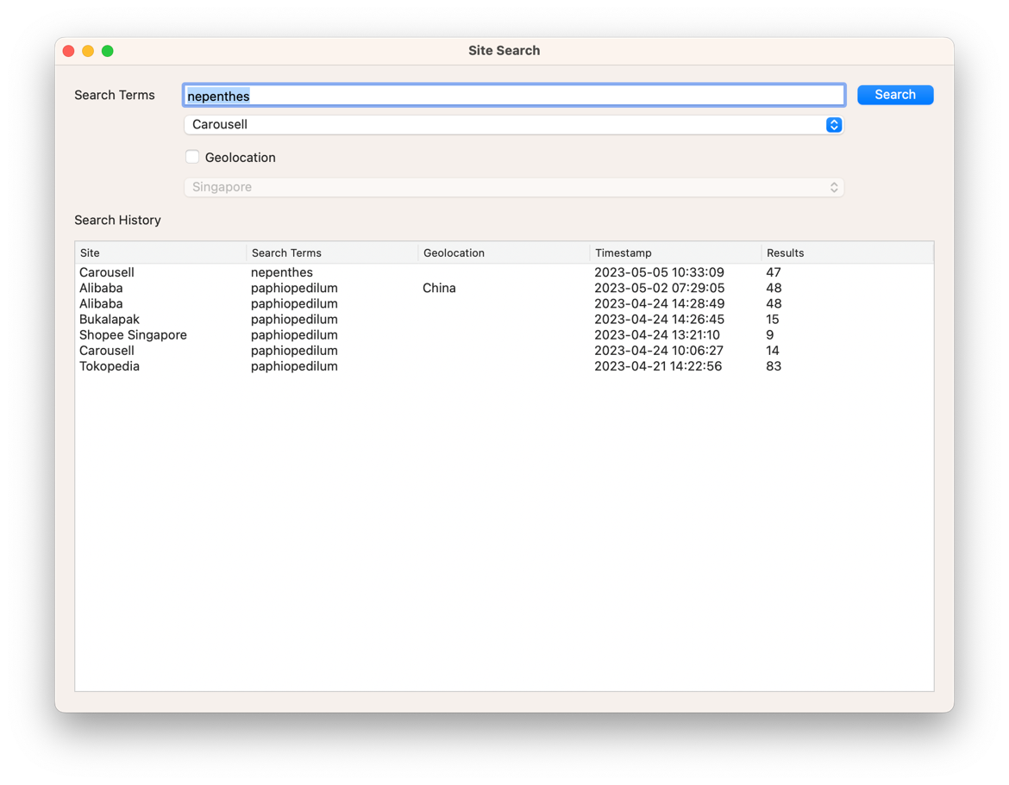

# Geolocation

Some sites either do not work well from some locations or show different results depending on the location of the request. It is possible to choose the location from where the request can be made by ticking the “Geolocation” checkbox and then choosing the country from the dropdown list below. Choosing the target site for a search also sets a default location that can optionally be used by ticking the “Geolocation” checkbox.

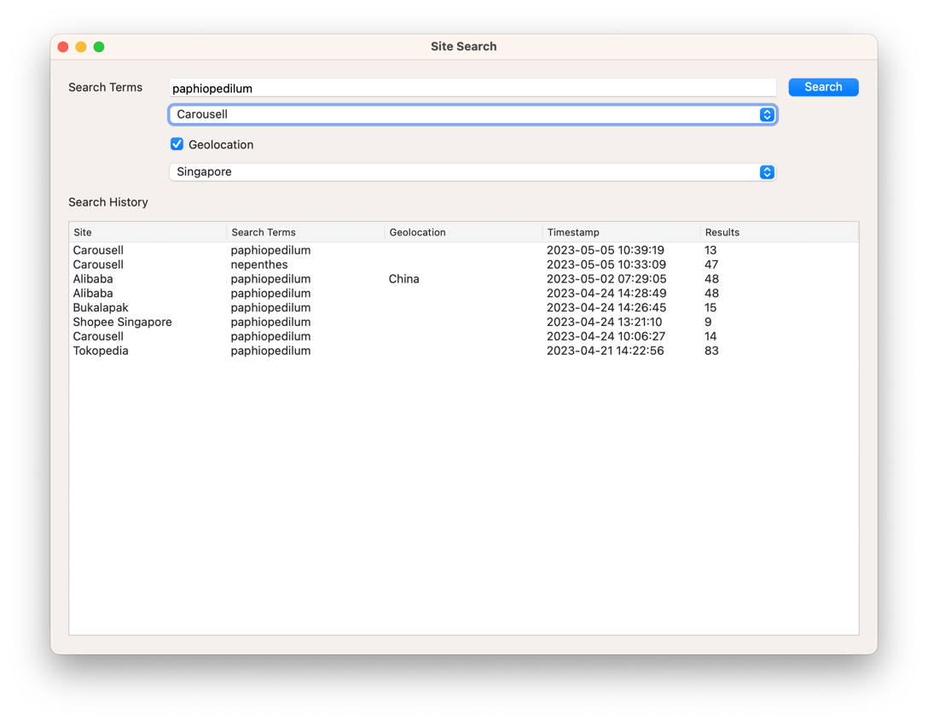

The country chosen for a search is shown in the search history list. An empty “Geolocation” field in list indicates that the default location has been used.

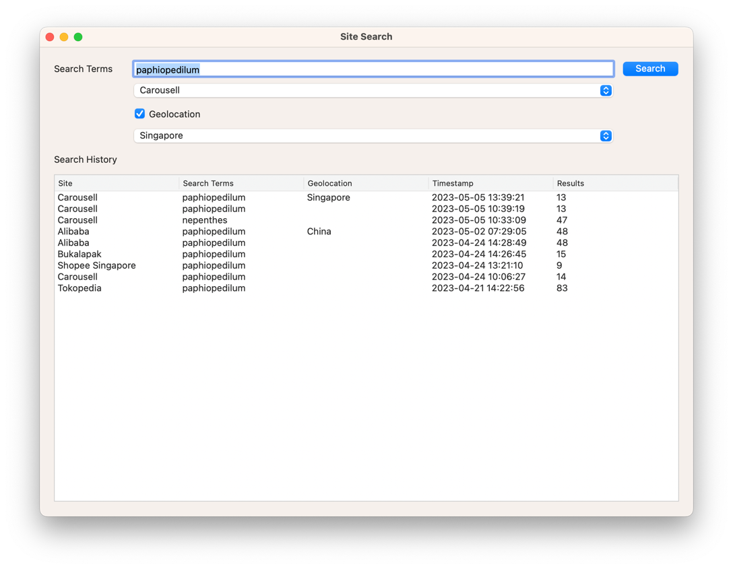

# Viewing Search Results

Results from an individual site search can be viewed by double-clicking on the search entry in the “Search History” list on the main application window. This will bring up a new window showing all of the results for that search. The “Search Terms” and the “Site Name” appear at the top of the “Search Results” window with a number of controls in the middle and a list of the individual results below.

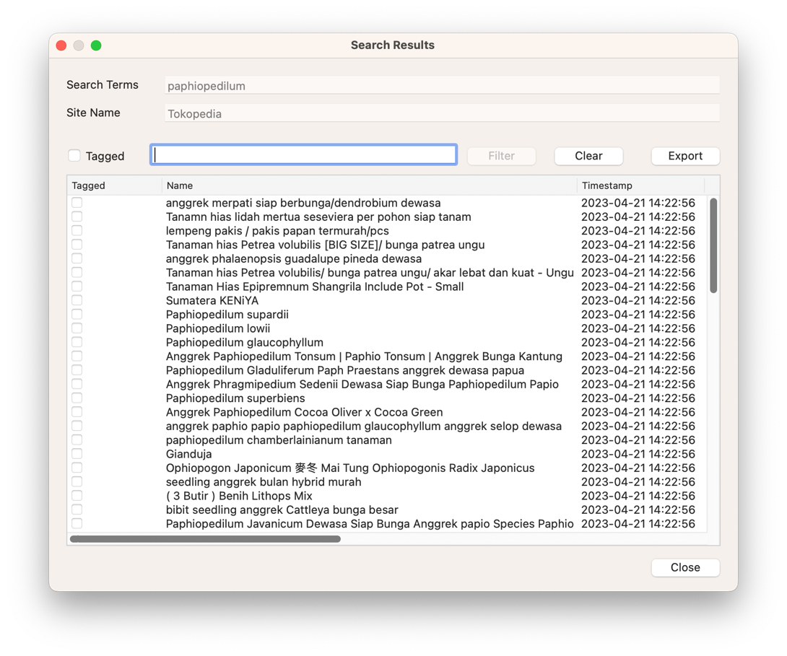

Scrolling up or down within the results list allows more results to be seen and it is also possible to expand the size of the “Search Results” window by dragging the window edges, in order to view more results at once.

The “Search Results” window can be closed by either clicking on the window close button at the top or by clicking on the “Close” button in the bottom right corner.

# Choosing Columns

The “Search Results” window shows the “Tagged”, “Name” and “Timestamp” columns by default but it is possible to select the columns that are being displayed. When more columns are being shown than will fit within the “Search Results” window, then a horizontal scrollbar will be shown to allow sideways scrolling.

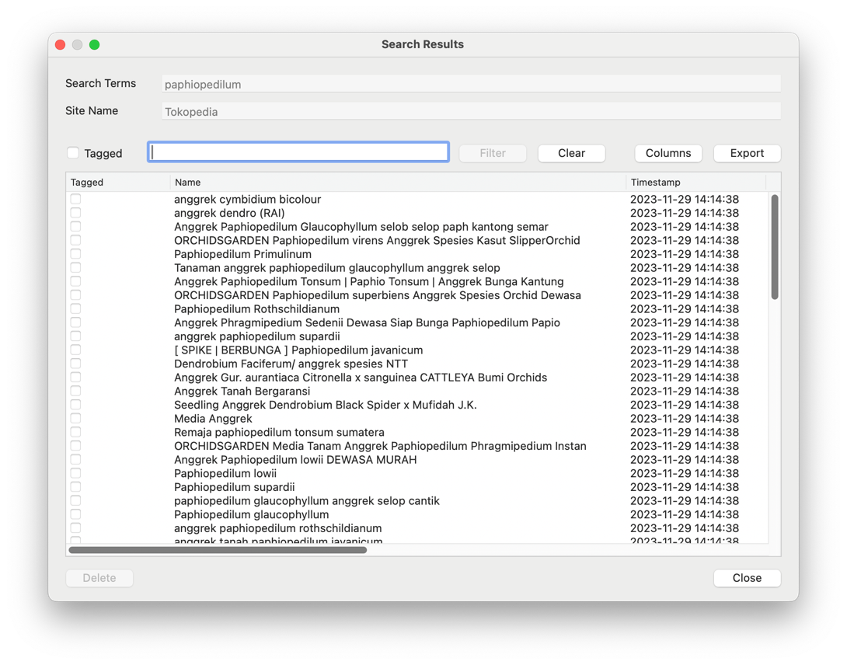

The columns can be selected by clicking on the “Columns” button. It can usually be found on the top right of the “Search Results” list, next to the “Export” button. Clicking on the “Columns” button will cause a “Results Fields” dialogue to be displayed.

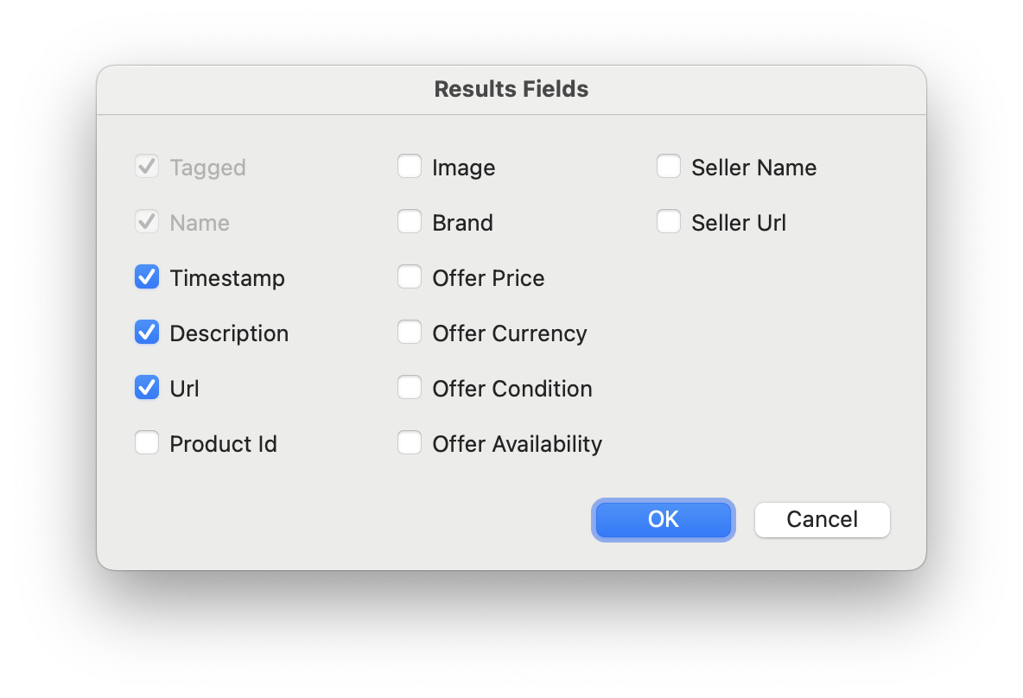

Individual fields (or columns) are shown or hidden by ticking or unticking the desired fields within the dialogue.

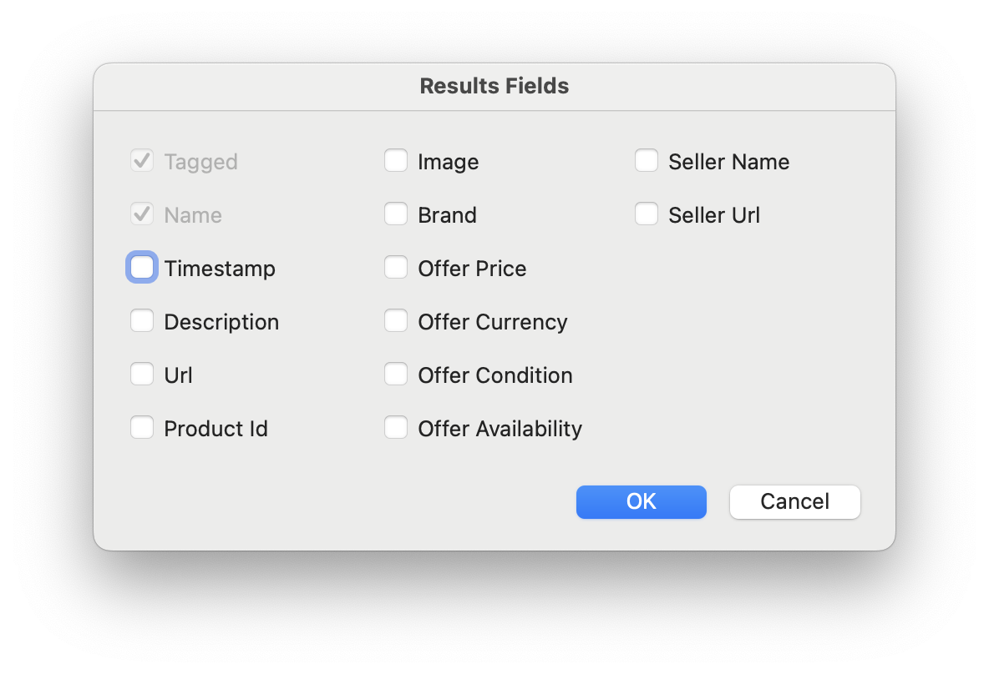

Clicking on the “Cancel” button will abandon the changes and return to the “Search Results” window with no changes being made. Clicking on the “Ok” button will confirm the choices and show the selected fields or columns.

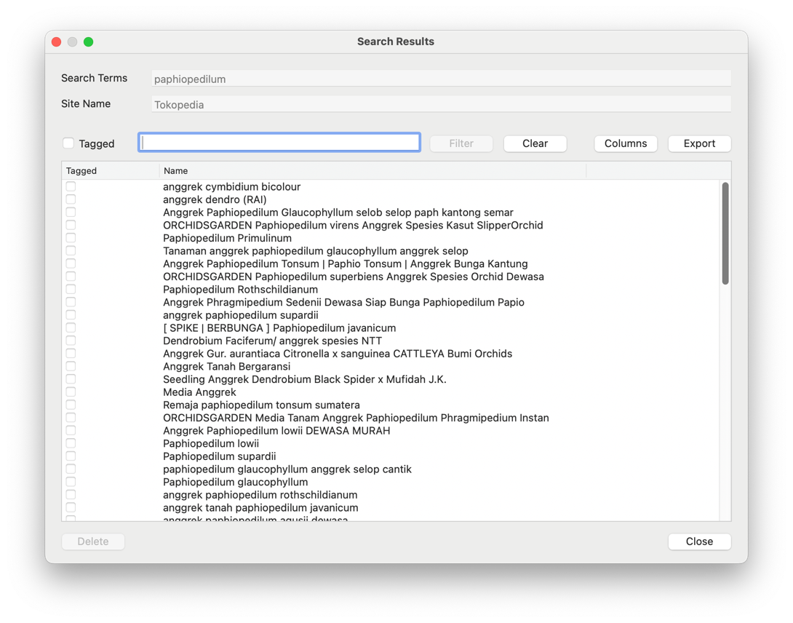

# Filter Search Results by Text

A list of search results in the “Search Results” window can be filtered by entering the desired filter terms in the text field and then pressing the return key or clicking the “Filter” button.

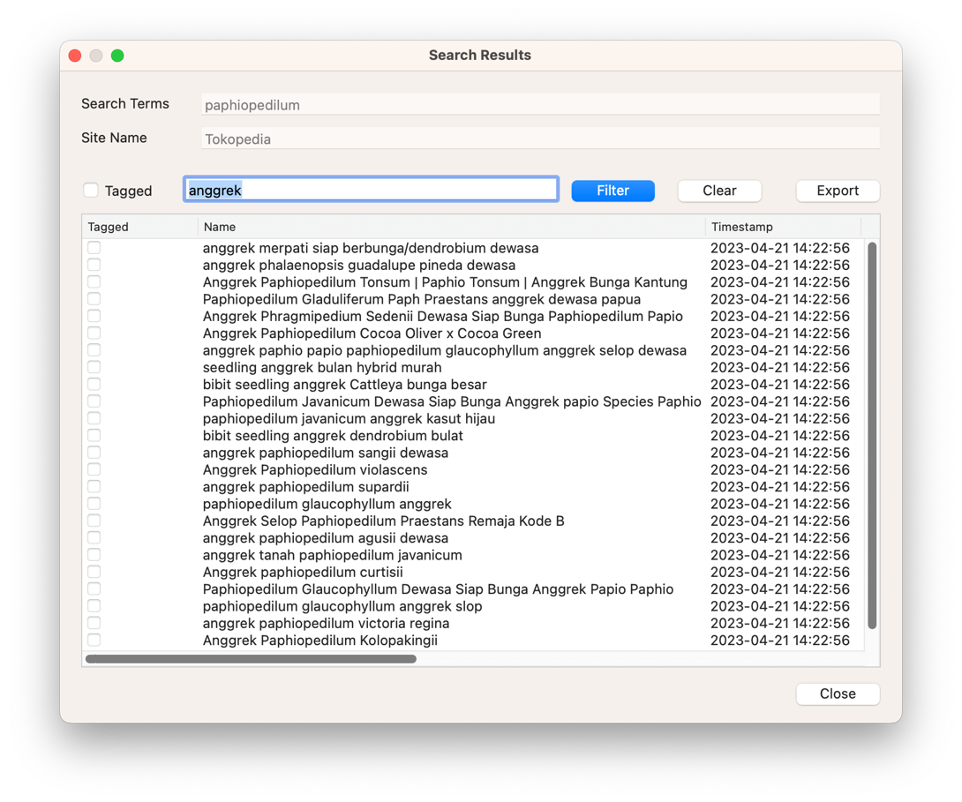

Pressing the “Clear” button removes the text filter and returns the results list to showing all of the results for that search (unless the “Tagged” tick box is set).

# Tagging Results of Interest

Individual items of interest can be tagged for filtering by ticking the “Tagged” tick box for a particular result item within the results list. The screenshot below shows a number of tagged items.

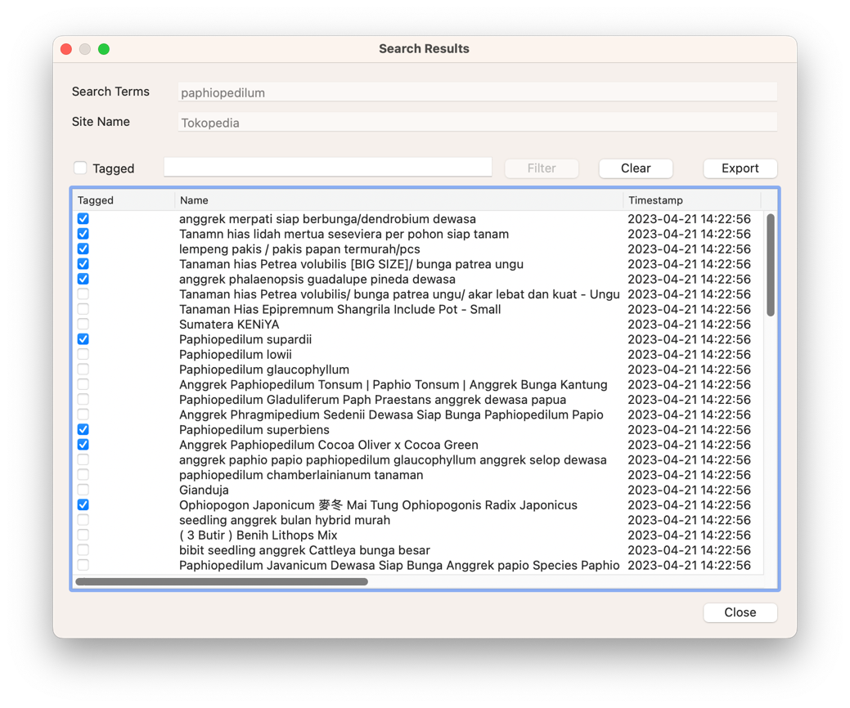

Once tagged, a “Tagged” filter can be applied by click on the tick box in the filter bar above the results list (between the “Clear” button and the “Export” button). This will then only show those items that are tagged.

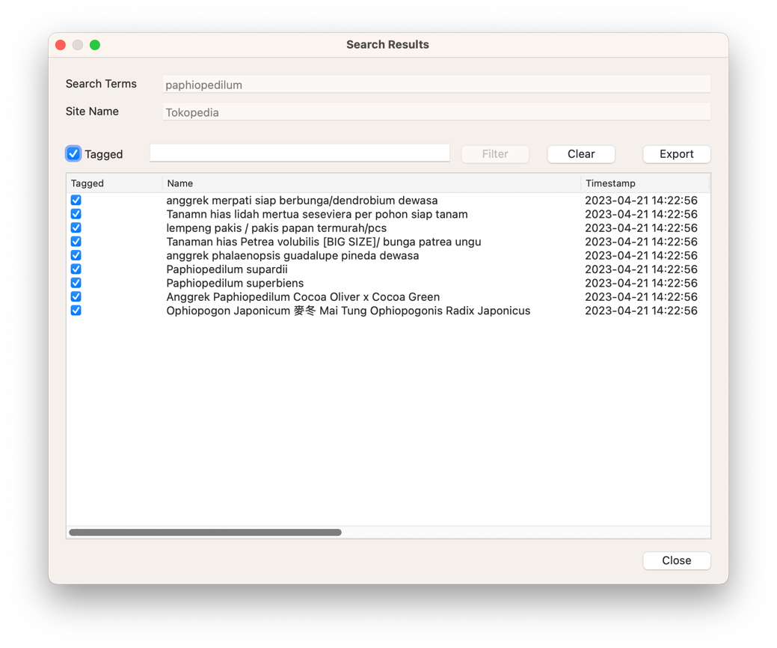

It is also possible to combine both a text filter and a tag filter in order to reduce the results list further.

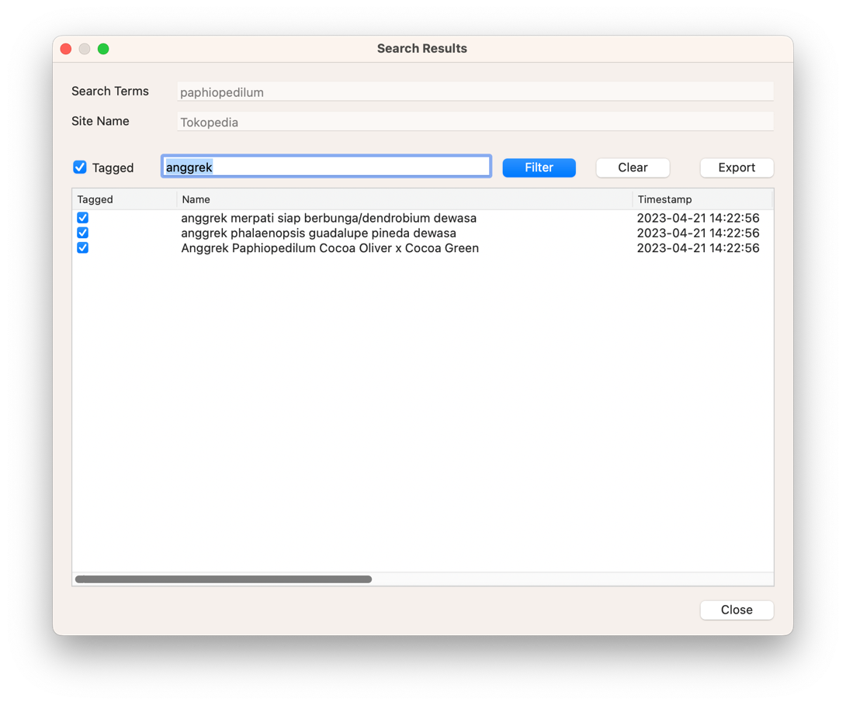

Removing the tag filter at this point would cause the results list to show all of the results with “anggrek” in their name. It is worth playing around with the combination of text and tag filters to see how they work together.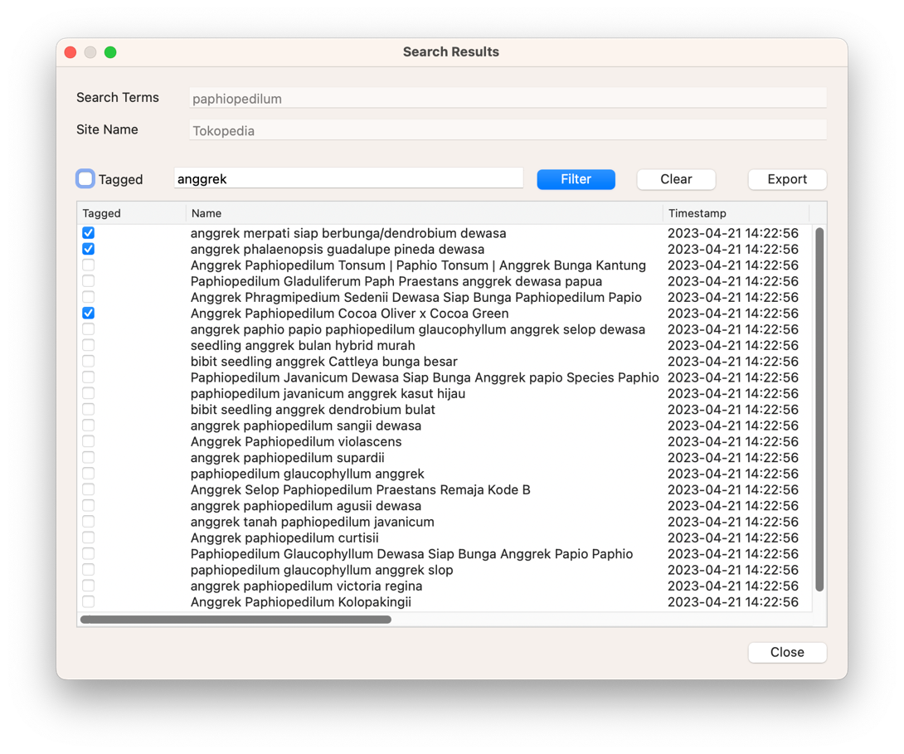

# Deleting Search Results

Individual search results can be deleted by going to the “Search Results” window and first selecting a result. The “Delete” button on the bottom left of the window will remain greyed out until a result is selected.



An individual result can be selected by clicking on that result in the list. The selected result will then become highlighted and the “Delete” button will now be enabled.

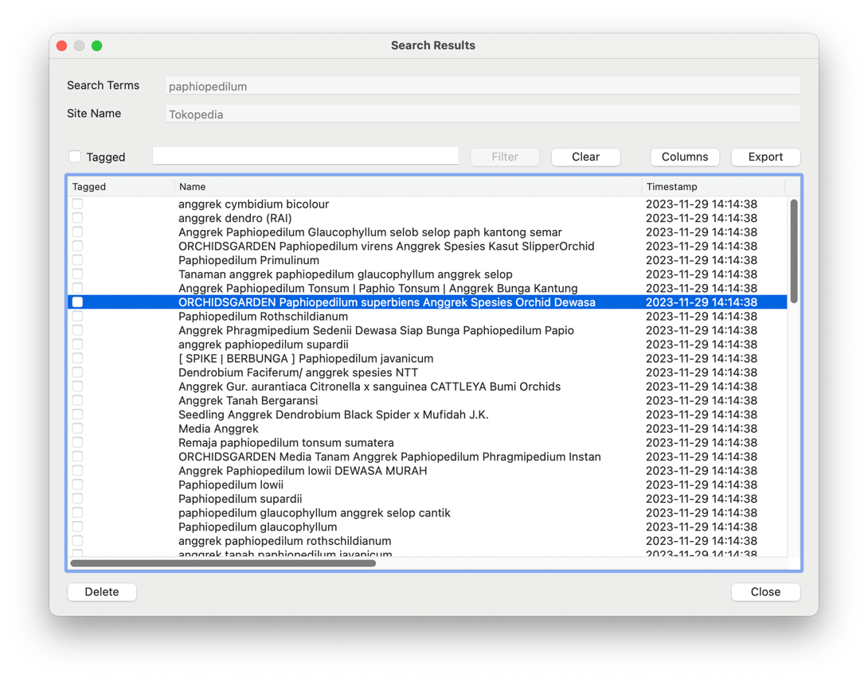

Click on the “Delete” button and a dialogue window will appear that asks for confirmation. Three options are available on the dialogue, but only clicking on the “Delete” option will confirm the action and perform the deletion. Selected either “Don’t Delete” or “Cancel” will return to the “Search Results” window with no changes being made.

**Deletion of a result is permanent, and it cannot be recovered.**

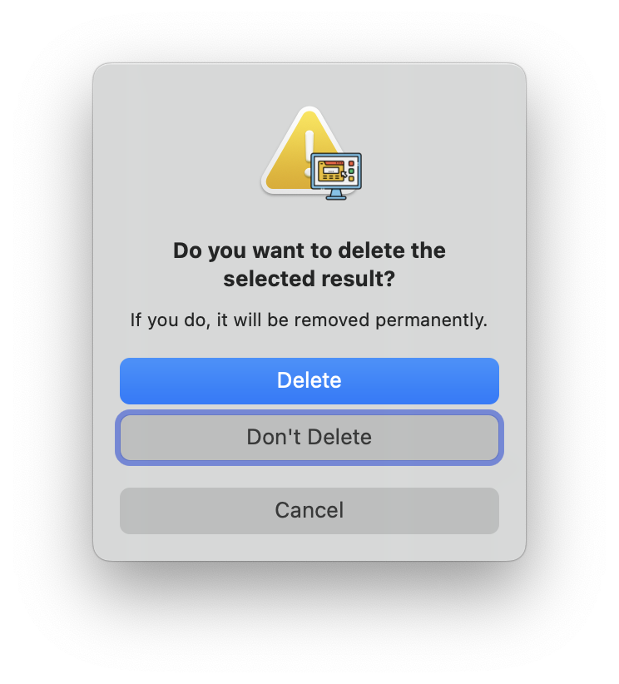

Once confirmed, the selected result will be removed from the list.

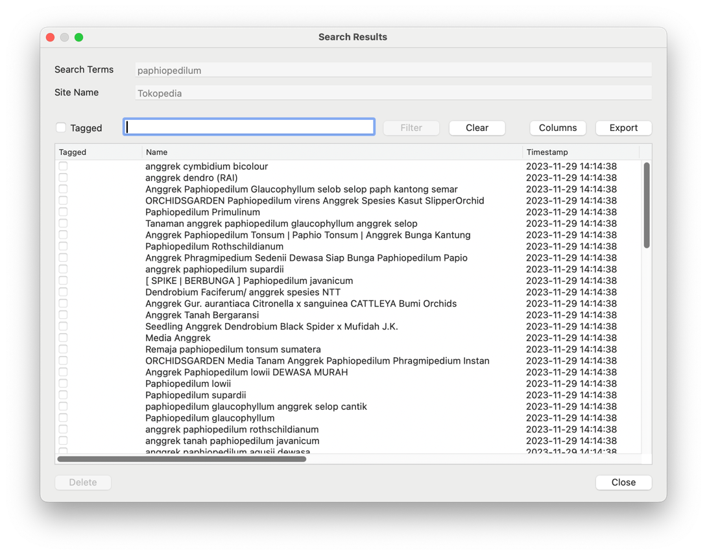

# Finding Search Results by Search Terms, Name or Seller

The “Edit -> Find” menu option allows for existing search results to be found by using a combination of the Search Terms, Name or Seller Name within those results.

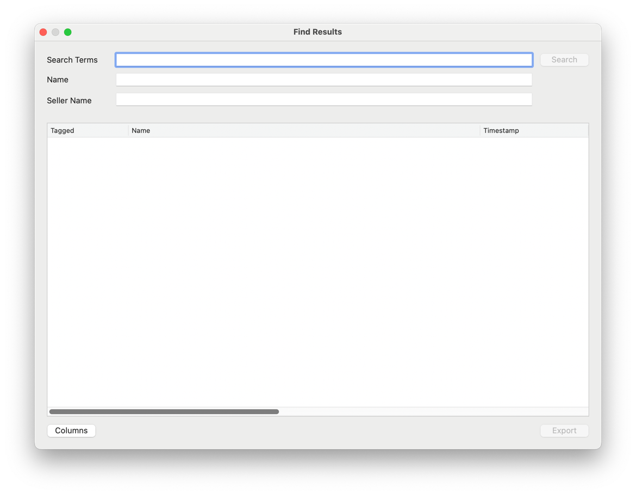

To find specific results, for example by name, enter the details in the appropriate search fields and then press the “Search” button. A list of the found results will then be displayed.

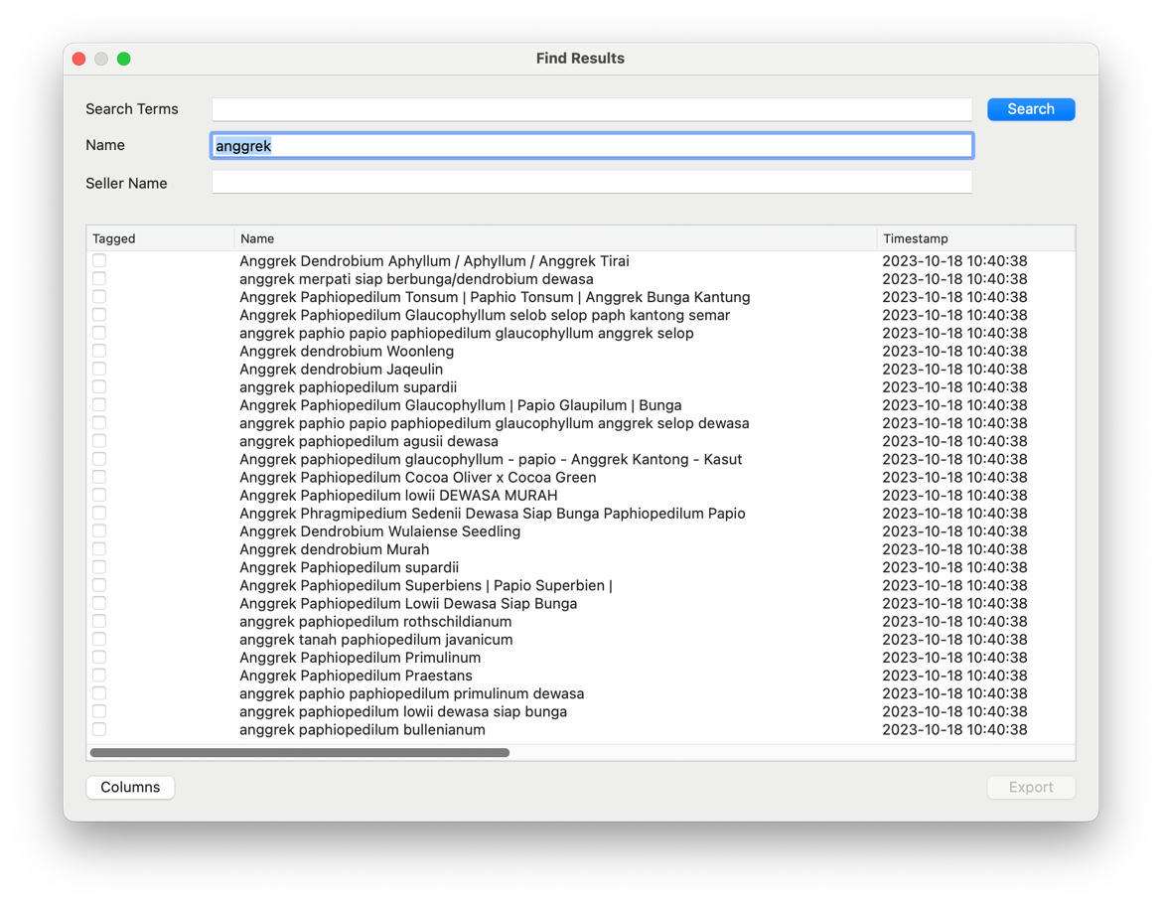

# Deleting Site Search History

Site search histories can be deleted by going to the “Site Search” window and first selecting an entry. The “Delete” button on the bottom left of the window will remain greyed out until a result is selected.

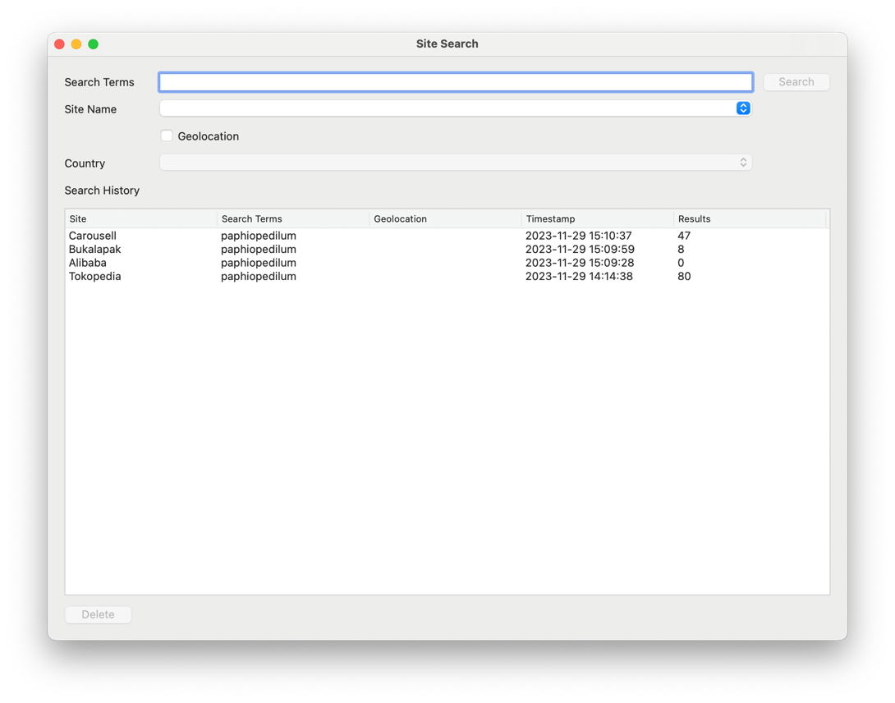

An individual entry can be selected by clicking on that entry in the “Search History” list. The selected entry will then become highlighted and the “Delete” button will now be enabled.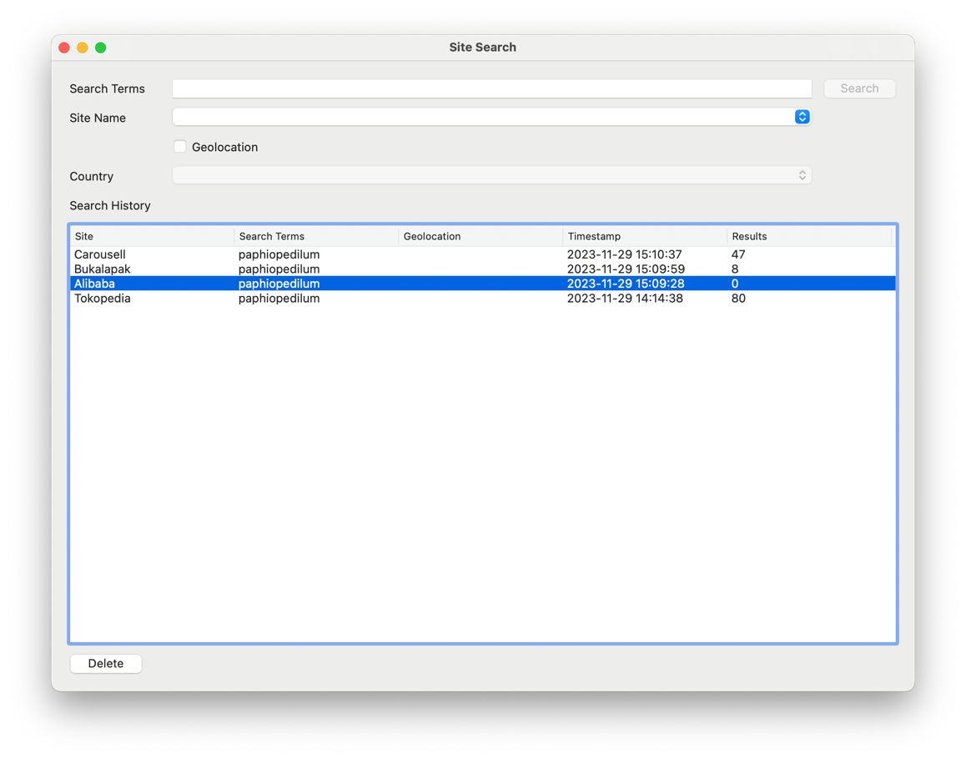

Click on the “Delete” button and a dialogue window will appear that asks for confirmation. Three options are available on the dialogue, but only clicking on the “Delete” option will confirm the action and perform the deletion. Selected either “Don’t Delete” or “Cancel” will return to the “Site Search” window with no changes being made.

**Deletion of a site search history is permanent, and it cannot be recovered.**

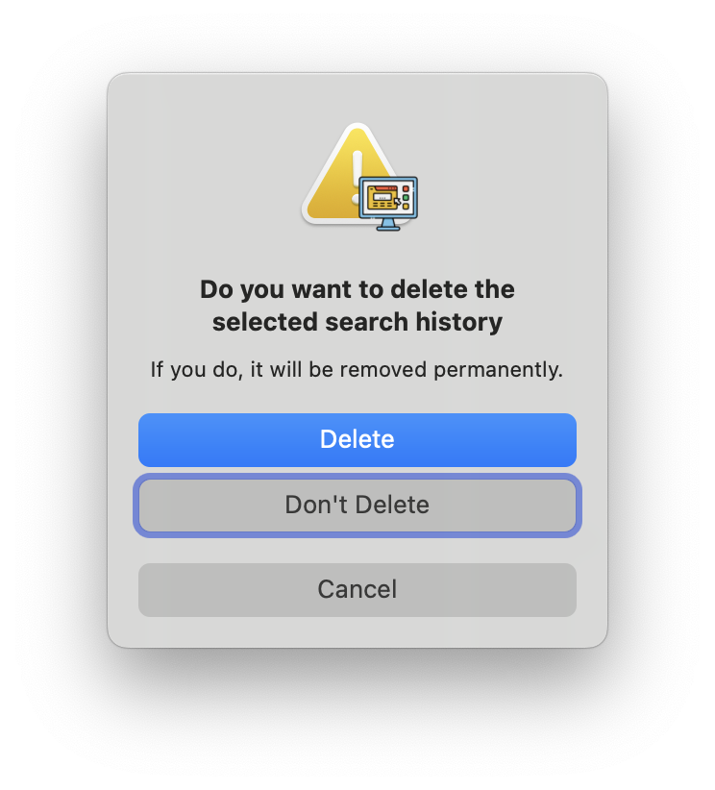

Once confirmed, the selected site search history entry will be removed from the list.

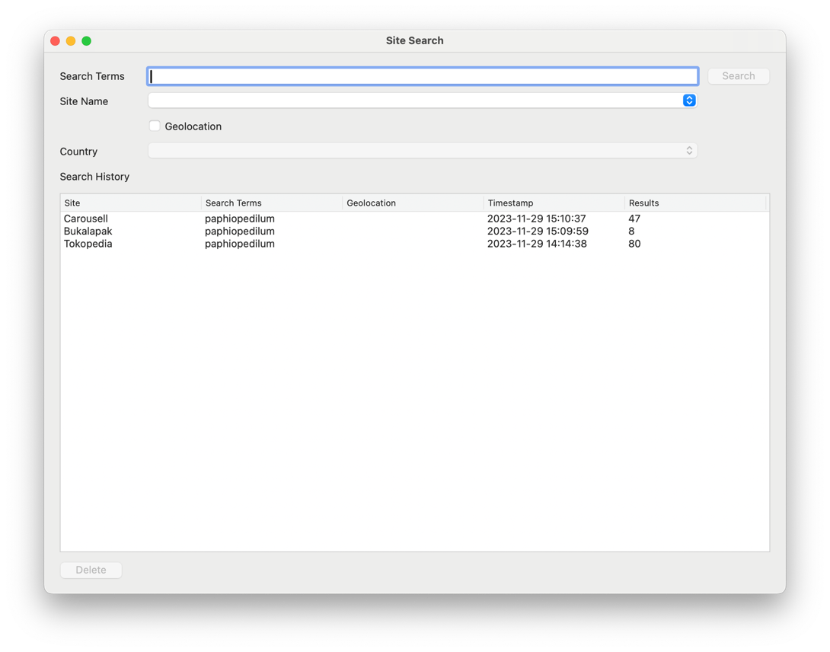

# Exporting the Search Results

The “Export” button on the “Search Results” window allows the results for an individual search to be exported in comma-separated values format (CSV). The file provides more fields than are currently shown in the search results list and also includes a header with the field names as the first row.

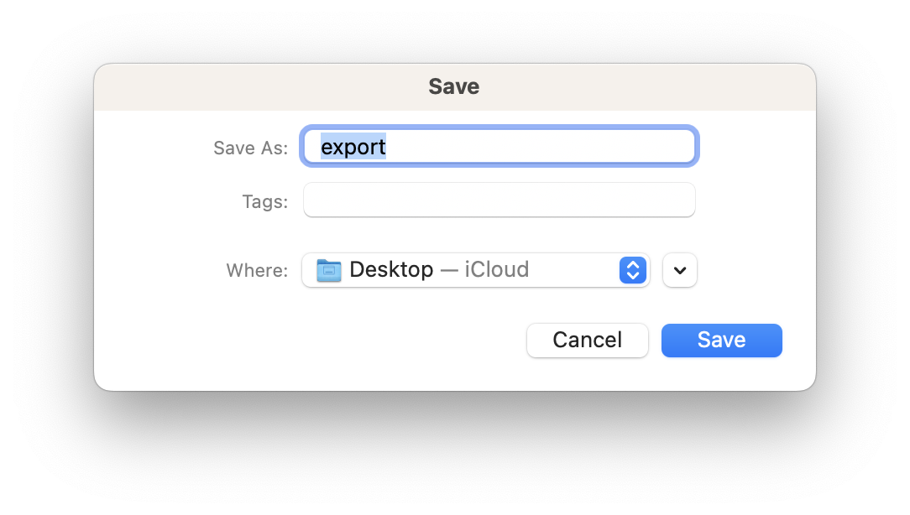

Pressing the “Export” button will produce a dialogue allowing the file location and filename to be chosen. Pressing the “Save” button within that dialogue causes the export to be performed.